Reflection for Good Friday 10.04.2020
By Jonny Bell

Luke 22:39-53

Jesus fears, the disciples sleep
The group come into the gardens, which may not have seemed too out of place for Jesus – we are told that it is his custom after all. Jesus tells the disciples to pray and moves a stone’s throw away from them. Jesus begins to pray; he knows that his actions during the Passover Festival, the challenging of the authorities and turning of tables in the Temple, would result in some sort of consequence.
Jesus knows that something is coming – pain, a pain that is so terrible that Jesus asks the father to have it taken away. “Remove this cup from me.” He asks, pleads, for another way. He does not want to endure what is coming. Yet, in Jesus’ perfect way, he still points to the Father’s will and not his own; “yet, not my will but yours be done.”
His fear is so great that his sweat becomes the size of drops of blood whilst he prays. Each drop edging him ever closer to the approaching, dreaded consequence.
He wakes up the disciples, despairing at their lack of awareness, despite being told over and over that something terrible is coming. The disciples tried their best but failed; they were full of food and drink and the hour was late. How did Jesus feel? To know that his closest friends were so oblivious to his fear and fate?
How many times have we succumb to our weaknesses and fallen spiritually asleep?
How many times have we not been aware of Christ’s urging in us?

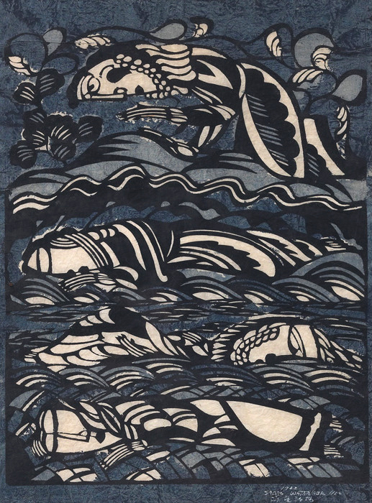

Sadao Watanabe (Japanese, 1913–1996), Garden of Gethsemane, 1962. Stencil print, 68.9 × 53.3 cm

Judas betrays Jesus
‘The one called Judas’, as Luke describes him, comes onto the scene with the ruckus of a crowd; bloody intent, anger shown in their swords and clubs contrasted by Judas’ own violence in a kiss. Why did he do this? Was Judas compelled to reveal the glory of a militant Messiah, a misconceived idea of a Messiah that would save Israel and liberate it from Rome? Or was he tired of Jesus’ inaction against the oppressors?
We cannot know, but we only know that we have been like Judas: we have betrayed Christ at times. We get tired of waiting, tired of loving, tired of having compassion. We choose to collude with oppressive forces to get some sort of action. A lapse, a giving into temptation, thinking we know best.
We know from Matthew’s gospel that the result for Judas was his suicide; can you imagine being in so much pain, feeling such guilt and shame, that you take your own life?

Pause
Feel what the different characters would have felt. The fear, confusion, guilt. Sit with these feelings and pray for the Spirit to rest with you in them.

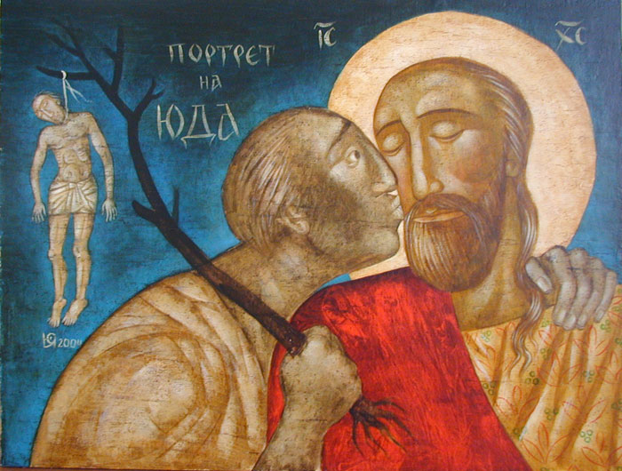

Julia Stankova (Bulgarian, 1954–), Portrait of Judas, 2004. Tempera, gouache, watercolours, and lacquer technique on wood, 45 × 60 cm. www.juliastankova.com

Luke 22:54-62

Peter denies Jesus
The story moves into the courtyard of the high priest, a large courtyard with rooms going around the edges and would have been used for official business. The crowd is there and Peter, having followed, sat with a few of them by a fire to warm up in the cold night.
I imagine that there would have been a lot of adrenaline coursing through Peter, set off by that fight or flight response in the body, caused by the arrest of Jesus. He would have felt uncertainty, anxiety and trepidation. His response to the others around the fire is understandable. I imagine he responded as such to keep both himself safe and to be able to stay close to Jesus as the authorities decide his fate.
“This man also was with him.” “Woman, I do not know him.”
“You also are one of them.” “Man, I am not!”
“Surely this man also was with him; for he is a Galilean.” “Man, I do not know what you are talking about!”
Given away by his accent. Called out. And then the realisation from the rooster’s noise and the look from Jesus.
Overcome, Peter left and bitterly wept.

Pause
Peter is often a character that ‘gets it wrong’: telling Jesus of no to need to suffer and being rebuked by Jesus, “Get behind be satan!” Of jumping onto the water with Jesus and then realising what is going on, sinking and needing saving by Jesus. And here, the denial of Jesus by Peter.
In John’s gospel, we have Jesus reinstating Peter. Three times Jesus asks, “Peter, do you love me?” With three responses from Peter, “Of course I love you!” Jesus reinstates, saying, “Then feed my sheep.”
How do we ‘get it wrong’? What times have we denied Christ? Offer them now, up to God in confession, and say to God, three times, that you love God. And, like Peter, we are reinstated, we are forgiven.

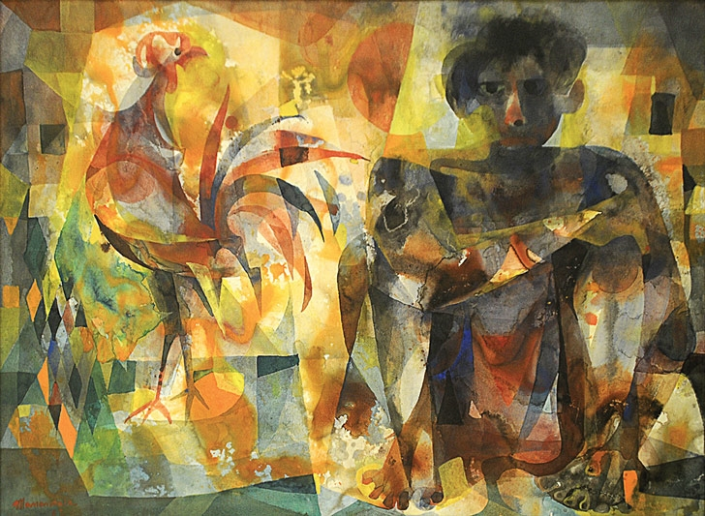
Vicente Manansala (Filipino, 1910–1981), Man with Rooster, 1963. Watercolour, 58.4 × 78.7 cm

Luke 22:63-23:25

Jesus before Pilate
In this part of the story, Jesus is bounced between the different leaders, with cruelty being heaped on him.
A trial where the Sanhedrin, the Jewish leaders, have already decided Jesus’ fate. I imagine that they didn’t like Jesus revealing their abuse of authority and power, so they condemn him. Yet we are reminded that not all the leaders were in favour with Jesus’ condemnation: reading later in 23:51 with Joseph of Arimathea. The leaders take Jesus to Pilate and, knowing that he didn’t care much for the Jewish laws, they falsely accuse Jesus of offences under Roman law.
Pilate, a politician, knows that tensions are high between the Jewish people and the Roman authorities. He wants things to remain calm and not to have a revolt. Finding no real fault with Jesus under the Roman law, he tried to plicate the crowd and have ‘one of their own’, Herod, confirm what he feels.
Herod, a man who is shown to be frivolous, treats Jesus as someone to bring him entertainment. He wants Jesus to perform for him. After some questioning and mocking, Herod sends him back to Pilate.
Neither Pilate nor Herod finds guilt in Jesus. Pilate attempts to plicate the crowd by saying he will punish Jesus and release him. The word ‘punish’ here means to scourge (a brutal and damaging punishment, often used as a run-up to crucifixion).
Unsatisfied, the crowds demand the release of Barabbas, a violent revolutionary, and the crucifixion of Jesus. It was the custom for the governor to release a prisoner at the Passover Festival, chosen by the people. Their persistence causes Pilate to give in. Afterall, what is the death of one man compared to the civil peace of a volatile state? Even if that man is innocent?
Jesus is condemned to death by crucifixion.

Pause
Take a moment to picture the scene, imagine it. Take a moment to breathe.

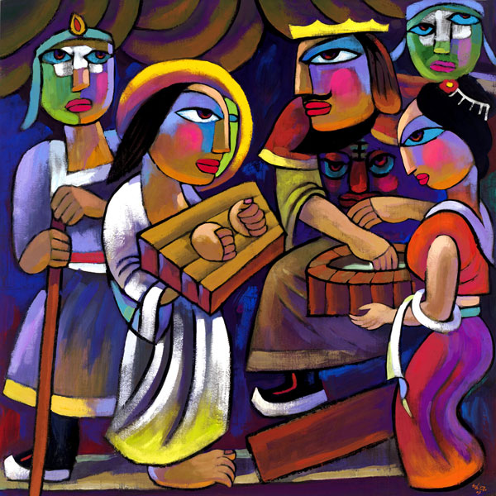

He Qi (Chinese, 1950–), Pilate Washing His Hands, 2007. Oil on canvas. www.heqiart.com

Luke 23:26-49

The women mourn
Jesus is paraded through the town, led up to the place called the Skull, Golgotha. Simon of Cyrene, visiting Jerusalem, is hauled in to carry the wooden beam of the cross, this would have slotted onto the post in the ground, making a T-shape.
People follow and the women who know Jesus also follow. They wailed and mourned. A loved one of theirs was suffering and soon to die and they were powerless to stop this. It was all so sudden; it was all so brutal. There would have been such pain and such paralyzing horror in their voices.

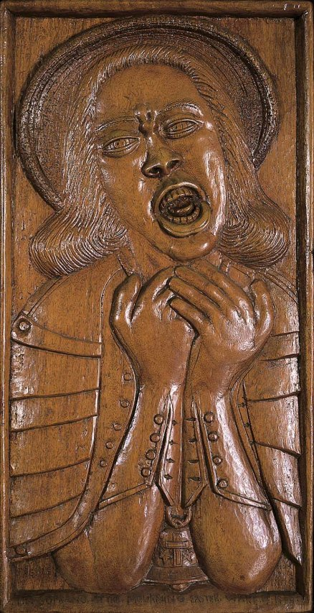 | Daniel Pressley  (American, 1918-1971)  The Soprano at the Mourning Easter Wake of 1968, 1968. Varnished walnut relief

Jesus is mocked
Jesus is mocked three times, first in 22:63-65 with the two soldiers; second in 23:11 with Herod; third in 23:36-38 by the cross. Cruelty is shown here in people’s actions and their lack of understanding. “Save yourself then if you are who you say you are!” They really don’t understand what Jesus is doing. They do not understand that Jesus is not there to save himself!
Here we are moving ever closer to that agony, taken on by our Saviour.

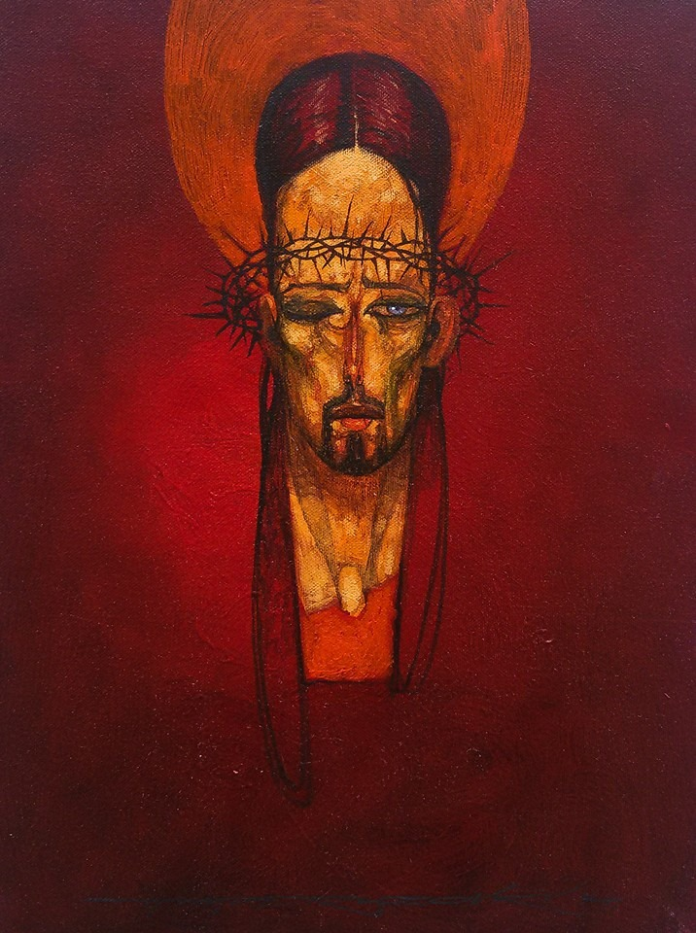 | Hrvoje Marko Peruzović (Croatian, 1971–),  Ecce Homo, 2014. Acrylic on canvas, 40 × 30 cm.  www.peruzovic.com

Jesus Dies
Now the nails have pierced his wrists and feet. There he hangs. The creator of all, the lover of all, the sovereign of all, is suspended, helplessly, on pieces of wood. His body, tired and bloody from the beatings and mocking, skin flayed from the scourging, head punctured by thorns, arms and legs impaled by metal. The God of all is reduced to an object of abjection, of brutal words and deeds and takes it all on. He is the Holy Victim of us all.
An awesome prayer is given, “Father forgive them, for they do not know what they are doing.” Amongst his pain, he still has love and compassion for the people who are causing it.
Two people convicted of crimes offer contrasting responses to the crucified Christ: one of scorn and rejection; the other of humility and acceptance.
At noon, darkness descends on the city. Jesus said to Judas and the crowd in 22:53, “But this is your hour, and the power of darkness.” Is this the power of darkness symbolically manifesting itself in the darkness of the sky?
With his last bit of energy, Jesus cries out, “Father, into your hands I commend my spirit.”
A centurion sees what happened and realises that it was something truly significant. The women remain with Jesus, at a distance.
Jesus dies.

Roberto Estopiñán (Cuban, 1921-2015), The Unknown Political Prisoner, 2008. Cast 2010, bronze

Pause
Use the song or the words to pray/reflect over Luke 23:26-49.
Lay It All Down
by United Pursuit, Will Reagan
Link to Video: https://www.youtube.com/watch?v=RNacm6zR8eU
Bring your worry, grief and pain
Every cause you have for shame
Lay it all down, lay it all down
When your cares have buried you
And there's nothing left to do
Lay it all down lay it all down
At the feet of Jesus, at the feet of Jesus
Carried on but your heart was tired
Feared the worst and felt the fire
Lay it all down, lay it all down
Filled with all those anxious thoughts
All your doubts became your god
Lay it all down, lay it all down
At the feet of Jesus, at the feet of Jesus
Lay it all down
Lay it all down
Lay it all down
Lay it all down
At the feet of Jesus
At the feet of Jesus
When we've given up on better days
There are memories we can't erase
Lay it all down, lay it all down
We've come to fear what we can't explain
There's nothing here that can ease the pain
Lay it all down, lay it all down
At the feet of Jesus, at the feet of Jesus

Luke 23:50-56

Jesus is buried
What usually happened to those who were crucified is that the body would be left there for several days and then taken down to be put into a common grave. Instead, permission is given for Joseph of Arimathea to take the body.
The women, who were witness to it all, take the body and bury it. The women remain with him until the very end.
The body is limp, lifeless; the face, swollen, bloody, lifeless; it doesn’t look like him anymore; he is lifeless.

Pause
Read the poem and reflect on the despair that the people would have felt. Their teacher, friend and loved one had been cruelly killed. Where is their hope?!
Read the poem and reflect on the hope that we know was revealed later. Their teacher, friend and loved one had been cruelly killed. But there is hope!
‘Although the wind’
by Izumi Shikibu
Although the wind
blows terribly here,
the moonlight also leaks
between the roof planks
of this ruined house.

John McLaughlin (American, 1898-1976) #13, 1973. Oil and acrylic on canvas

